DHA Suffa University
Department of Computer Science
Final Year Project


CapstoneConnect
P-2067
Project Proposal
Submitted by

AYUSHMANN KUKREJA (CS201245)
ABDUL REHMAN KHAN(CS201250)
MURTAZA MEHDI(CS201211)
Supervisor(s)

Supervisor Name: Ms. UROOJ WAHEED
Co-Supervisor Name: Mr. YUSRA MANSOOR

In partial fulfilment of the requirements for the degree of
Bachelor of Science in Computer Science
FALL 2022
Document Sign-off Sheet

Document Information

Project Title | CapstoneConnect
Document | Project Proposal
Document Version | 1.0
Identifier | FYP01-PP
Status | < Draft/ Final / etc..>
Author(s) | Ayushmann Kukreja  Murtaz Mehdi  Abdul Rehman Khan
Approver(s) | Ma’am Urooj Waheed
Issue Date | 28/11/2023

Team Lead Name:AYUSHMANN KUKREJA Signature: _____________ Date: 28/12/2023

Member 1 Name:ABDUL REHMAN KHAN Signature: ______________Date:28/12/2023

Member 2 Name:MURTAZA MEHDI Signature: ______________Date:28/12/2023

Supervisor Name: UROOJ WAHEED Signature:______________Date:28/12/2023

Co-Supervisor Name: YUSRA MANSOOR Signature: ______________Date:28/12/2023

Revision History

Date | Version | Description | Author
25/11/2023 | 1.0 | Initial Document, Discussion Regarding Project Proposal | Ayushmann Kukreja  Murtaza Mehdi  Abdul Rehman

Definition of Terms, Acronyms, and Abbreviations

Term | Description
FYP | Final Year Project
SDLC | Software Development Life Cycle
GUI | Graphical User Interface

Table of Contents
Document Information 2
Definition of Terms, Acronyms, and Abbreviations 2
Table of Contents 3

1 Introduction
1.1 Problem Statement
1.2 Product Position Statement
1.3 Project Motivation and Background
1.4 Objectives

2 Project Vision
2.1 Business Case and SWOT Analysis
2.2 Stakeholder Summary
2.3 User Summary
2.4 Business Objectives and Success Criteria
2.5 Project Risks and Risk Mitigation Plan
2.6 Assumptions and Dependencies

3 Project Scope
3.1 In Scope
3.2 Out of Scope

4 Proposed Methodology
4.1 SDLC Approach (Waterfall/Agile/Spiral)
4.2 Team Role & responsibilities
4.3 Requirement Development Methodology
4.4 High level Architecture / Design

5 Project Planning
5.1 Gantt Chart

6 Project Requirements
6.1 Software tools requirements
6.2 Hardware requirements

7 Budget/Costing
7.1 Estimated Budgeted Cost of the Project

8 Project Deliverables (you may change according to your project methodology)
8.1 Phase I - Alpha Prototype
8.2 Phase II - Beta Prototype
8.3 Phase III - Release Candidate
8.4 Phase IV - Final Product

9 Proposed GUI (Prototype)

10 Meetings held with supervisor and/or client.
1. Introduction

  - Problem Statement

In the realm of academic capstone projects, the current process of project selection, collaboration, and supervision lacks a centralized and efficient platform. Students, faculty, and industry stakeholders often face challenges in seamlessly connecting, communicating, and managing the various aspects of the capstone project lifecycle. This gap hinders the potential for meaningful collaboration, leading to suboptimal project outcomes and a less-than-optimal learning experience for students.

The absence of a dedicated and user-friendly Capstone Connect portal results in a lack of transparency in project availability, a cumbersome project matching process, and ineffective communication channels. As a consequence, students may struggle to find suitable projects, faculty may face difficulties in overseeing multiple projects, and industry partners may miss out on opportunities to engage with motivated and capable students.

To address these challenges, there is a pressing need for an integrated Capstone Connect portal that streamlines the project selection process, facilitates efficient communication among stakeholders, and enhances the overall management of capstone projects. This portal should serve as a central hub for students, faculty, and industry collaborators, fostering collaboration, transparency, and a more enriching capstone project experience.

1.2 Product Position Statement:

CapstoneConnect is a pioneering solution poised to transform the landscape of Final Year Project (FYP) management within academic institutions. As the ultimate connector in the academic journey, CapstoneConnect serves as a centralized and intuitive portal, revolutionizing the way students and supervisors engage with the FYP process. Seamlessly facilitating communication, transparent progress monitoring, and streamlined documentation, CapstoneConnect is more than a portal; it's a catalyst for collaborative excellence. Embrace a new era in academic project management with CapstoneConnect – where connectivity meets innovation for an unparalleled Capstone experience.

1.3 Project Motivation and Background

Background:

Traditionally, the management of Final Year Projects has been marked by disjointed communication channels, manual tracking methods, and a lack of standardized processes. Students encounter challenges in submitting project proposals, tracking progress, and receiving timely feedback, while supervisors face difficulties in managing multiple projects efficiently. The absence of a centralized platform exacerbates these issues, leading to a suboptimal FYP experience for all stakeholders.

Recognizing these challenges, our project seeks to address the shortcomings in the current FYP management system by introducing "CapstoneConnect," a comprehensive and user-friendly portal dedicated to streamlining the entire FYP process.

Motivation:

The motivation behind the development of CapstoneConnect stems from a commitment to enhancing the quality, transparency, and efficiency of the FYP experience. By creating a centralized hub for all FYP-related activities, CapstoneConnect aims to revolutionize how students and supervisors interact, collaborate, and progress through the FYP lifecycle.

Through extensive research and stakeholder consultations, it has become clear that an integrated FYP portal is not just a convenience but a necessity. CapstoneConnect seeks to fill the existing gaps in communication, documentation, and progress tracking, providing a transformative platform that aligns with the institution's commitment to academic excellence and innovation.

In summary, CapstoneConnect is not just a portal; it's a strategic response to the challenges inherent in the current FYP management system. By fostering connectivity, transparency, and efficiency, CapstoneConnect aims to redefine the Final Year Project experience for all stakeholders involved, laying the groundwork for a more collaborative and successful academic journey.

1.4 Objectives

1. Develop a User-Friendly Portal:
Create an intuitive and user-friendly interface for both students and supervisors to navigate seamlessly through the CapstoneConnect portal.

2. Centralize Communication:
Establish a centralized communication hub within CapstoneConnect to facilitate efficient and transparent interactions between students and supervisors.

3. Streamline Project Management:
Implement robust project management features to streamline the submission of project proposals, progress tracking, and milestone management.

4. Previous Projects showcase:
To provide a repository of past FYPs for students to gain inspiration and insights.
To showcase the diversity and quality of projects undertaken by students in previous years.

5. Enable Supervisor Allocation and Matching:
Develop a system for supervisor allocation based on student preferences and project compatibility, ensuring a fair and efficient matching process.

6. Implement Progress Tracking Tools:
Integrate progress tracking tools within CapstoneConnect to enable real-time monitoring of project milestones, facilitating proactive supervision and feedback.

7. Incorporate Evaluation and Grading Features:
Implement a comprehensive evaluation and grading system that allows supervisors to assess project submissions and provide constructive feedback.(admin)

8. Provide Analytics and Reporting:
Develop analytics and reporting functionalities within CapstoneConnect to generate insights into project trends, progress, and other relevant metrics.

9. Promote Security and Data Privacy:
Implement robust security measures to protect user data and ensure compliance with data protection and privacy regulations.

10. Conduct User Testing and Feedback:
Conduct thorough user testing to gather feedback from students, supervisors, and administrators, and iteratively improve CapstoneConnect based on the collected insights.

11. Enable Scalability:
Design CapstoneConnect to be scalable, accommodating potential growth in the number of users and projects as the institution expands.

12. Provide Documentation and Training:
Offer comprehensive documentation and training materials to assist users in navigating and maximizing the features of CapstoneConnect.

13. Ensure Successful Deployment and Adoption:
Strategize a smooth deployment process for CapstoneConnect, accompanied by communication and training initiatives to ensure successful adoption by all stakeholders.

By achieving these objectives, CapstoneConnect aims to revolutionize the Final Year Project experience, providing a comprehensive and efficient platform for students, supervisors, and administrators within the academic institution.

2. Project Vision

2.1 Business Case and SWOT Analysis

Business Case:
Institutional success in academic excellence is inherently tied to the seamless execution of Final Year Projects (FYPs). Recognizing the current challenges in FYP management, we propose the development and implementation of CapstoneConnect, a dedicated FYP portal designed to revolutionize the entire project lifecycle.

Benefits

Efficiency: CapstoneConnect streamlines the FYP process, reducing administrative burdens and improving overall project management efficiency.

Transparency: Centralized communication and progress tracking enhance transparency, providing stakeholders with real-time insights into project milestones.

Quality: Improved documentation and collaboration contribute to the overall quality of FYP submissions and evaluations.

User Satisfaction: A user-friendly interface and features tailored to the needs of students and supervisors contribute to increased user satisfaction.

Cost-Benefit Analysis:

The investment in developing and implementing CapstoneConnect will be offset by the long-term benefits of improved efficiency, reduced delays, and enhanced project quality. The costs include initial development, deployment, and training, whose benefits encompass increased productivity, better resource utilization, and a positive impact on the institution's academic reputation.

Risk Analysis:

Potential risks include resistance to change, technical challenges during implementation, and user adoption issues. Mitigation strategies involve comprehensive communication and training plans, iterative testing, and ongoing user support.

Implementation Plan:

The phased implementation of CapstoneConnect includes development, testing, user training, and deployment. Stakeholder involvement and feedback loops will be integrated into each phase to ensure a tailored and successful rollout.

CapstoneConnect is a strategic investment that aligns with our institution's commitment to academic excellence. By addressing existing challenges in FYP management, this initiative has the potential to positively impact student experiences, improve academic outcomes, and position our institution as a leader in innovative academic project management.

This business case outlines the compelling need for CapstoneConnect, detailing its objectives, benefits, cost-benefit analysis, risk analysis, and a comprehensive implementation plan. This proposal is positioned to usher in a new era in FYP management, providing a holistic solution to current challenges and contributing to the continued success of our academic community.

SWOT Analysis

 | Strengths | Weaknesses | Opportunities | Threats
1 | Innovation in FYP Management:  CapstoneConnect introduces an innovative solution to address the current challenges in Final Year Project (FYP) management within our institution. Innovation in FYP Management:  CapstoneConnect introduces an innovative solution to address the current challenges in Final Year Project (FYP) management within our institution. | Initial Implementation Costs:  The development and initial implementation of CapstoneConnect may incur upfront costs, including software development, deployment, and training expenses. | Market Adoption and Expansion:  Successful implementation of CapstoneConnect presents an opportunity for adoption by other educational institutions, potentially leading to expansion and collaboration. | Competitive Solutions:  The emergence of competing solutions in the market poses a threat to CapstoneConnect's adoption and acceptance.
2 | Comprehensive Project Features:  The portal offers a wide range of features, including centralized communication, progress tracking, documentation, and collaborative tools, providing a holistic solution for FYP stakeholders | Resistance to Change:  There might be resistance from stakeholders accustomed to the existing FYP management processes, requiring effective change management strategies. | Continuous Improvement:  The iterative nature of software development allows for continuous improvement based on user feedback and evolving institutional needs. | Data Security Concerns:  Potential concerns regarding data security and privacy may arise, requiring robust security measures to address and mitigate these threats.
4 | Aligned with Academic Goals:  The project aligns with the institution's commitment to academic excellence and innovation, enhancing the overall quality of FYP experiences.

2.2 Stakeholder Summary

Type | Description | Responsibilities
Students (Primary Stakeholders) | The primary beneficiaries of the CapstoneConnect project are the students undertaking Final Year Projects (FYPs). They will use the platform for proposal submission, progress tracking, and communication with supervisors. | Actively engage with the CapstoneConnect portal for project management.  Submit project proposals, updates, and required documentation.  Utilize communication features to interact with supervisors and peers.  Provide feedback on the usability and effectiveness of the portal.
Supervisors (Primary stakeholders) | Faculty members serving as project supervisors play a critical role in guiding and evaluating students throughout the FYP process. They will use CapstoneConnect to monitor progress, provide feedback, and assess project submissions. | Access and navigate CapstoneConnect for supervising multiple FYPs.  Track project milestones, review submissions, and provide timely feedback.  Use communication tools to interact with students and fellow supervisors.  Participate in training sessions and provide feedback for system improvement.
Administrators (Key stakeholders) | Institutional administrators oversee the overall academic processes and ensure the successful integration of CapstoneConnect into existing systems. | Support the implementation and deployment of CapstoneConnect.  Ensure alignment with institutional goals and policies.  Oversee user training initiatives and coordinate with IT support.  Monitor the platform's impact on overall academic outcomes.
Externals (Indirect Stakeholders) | External stakeholders may include potential employers, alumni, or industry partners interested in the quality and outcomes of FYPs. Their indirect involvement may influence the reputation and success of the CapstoneConnect initiative. | May engage with the platform to review project outcomes.  Provide feedback on the relevance and impact of FYPs in the industry.  Potentially offer collaboration opportunities for future projects.

2.3 User Summary

Students:

User Type: Primary Stakeholders
Summary:
Students are the primary users of CapstoneConnect, relying on the platform for managing their Final Year Projects (FYPs). They will engage with the portal to submit project proposals, track progress, communicate with supervisors, and access resources.

User Characteristics:
Diverse academic backgrounds.
Varied levels of technological proficiency.
High engagement during FYP lifecycle.

Supervisors:

User Type: Primary Stakeholders
Summary:
Supervisors play a key role in guiding and evaluating students' FYPs. They will use CapstoneConnect to monitor project milestones, review submissions, provide feedback, and communicate with students.

User Characteristics:
Faculty members with diverse expertise.
Busy schedules managing multiple FYPs.
Varied levels of technological proficiency.

Administrators:

User Type: Key Stakeholders
Summary:
Administrators oversee the overall implementation and integration of CapstoneConnect into institutional processes. They may use the portal for monitoring overall academic outcomes and ensuring alignment with institutional goals.

User Characteristics:
Decision-makers at the institutional level.
Concerned with system integration and policy alignment.
May not be directly involved in day-to-day FYP activities.

User Type: Indirect Stakeholders
Summary:
External stakeholders include potential employers, alumni, or industry partners interested in the quality and outcomes of FYPs. They may engage with the portal to review project outcomes and offer feedback.

User Characteristics:
Varied backgrounds in industry and academia.
Interested in the relevance and impact of FYPs in the industry.
Indirect influence on the success and reputation of the FYP program.

2.4 Business Objectives and Success Criteria:

Optimize FYP Management:
Success Criteria:
Reduction in the time spent on administrative tasks related to FYP management.
Increase in the overall efficiency of the FYP process, from proposal submission to project evaluation.

Enhance Communication and Collaboration:
Success Criteria:
Improvement in communication efficiency between students and supervisors.
Increased collaboration, as evidenced by a rise in joint project activities or contributions.

Improve Documentation Processes:
Success Criteria:
Reduction in documentation errors or omissions.
Increase in the completeness and organization of project-related documentation.

Increase User Satisfaction:
Success Criteria:
Achieve a user satisfaction rate of at least 80% based on feedback surveys.
Increase in positive user testimonials and endorsements.
Enable Data-Driven Decision Making:

Success Criteria:
Implementation of analytics and reporting features within six months of CapstoneConnect launch.
Regular use of data-driven insights for decision-making by administrators and educators.

Ensure Security and Compliance:
Success Criteria:
Zero major security incidents reported within the first year of CapstoneConnect implementation.
Full compliance with relevant data protection and privacy regulations.
Facilitate Scalability:

Promote System Integration:

Success Criteria:
Integration of CapstoneConnect with at least two existing institutional systems within the first year.
Seamless interoperability with other academic platforms used by the institution.

Achieve High User Adoption Rates:
Success Criteria:
90% of eligible students actively use CapstoneConnect within the first semester.
80% of supervisors regularly engage with the platform for project management.

Monitoring and Evaluation:
Key Performance Indicators (KPIs):

Monthly active users.
Average time spent per session on the CapstoneConnect portal.
Number of successfully completed projects using the platform.
Feedback Mechanisms:

Regular surveys to gather user feedback.
Periodic focus groups with students, supervisors, and administrators.
Continuous monitoring of support tickets and issue resolution times.
Regular Review and Iteration:

Quarterly reviews of key metrics and success criteria.
Iterative development based on user feedback and emerging needs.
Annual reassessment of business objectives and realignment with institutional goals.
By defining clear business objectives and success criteria, the CapstoneConnect project aims to measure its impact on FYP management and continuously enhance the user experience, fostering innovation and improvement within the academic institution.

2.5 Project Risks and Risk Mitigation Plan

Project Risks: We will have very few risks including

1. Technical Challenges:
Risk:
Unforeseen technical issues during the development and implementation phases.
Mitigation:
Conduct thorough feasibility studies and prototype testing before full-scale development.
Engage in regular communication and collaboration with the IT department to address technical concerns promptly.
Allocate contingency time in the project schedule to address unexpected technical challenges.

2. Resistance to Change:
Risk:
Stakeholders, particularly students and supervisors, may resist adopting the new system.
Mitigation:
Implement a robust change management strategy, including communication plans and training sessions.
Highlight the benefits of CapstoneConnect, emphasizing how it addresses current challenges and enhances the overall FYP experience.
Encourage and incorporate feedback from users during the development process to increase stakeholder buy-in.

3. Data Security Concerns:
Risk:
Concerns regarding the security and privacy of user data.
Mitigation:
Implement robust data encryption protocols to secure sensitive information.
Conduct regular security audits and vulnerability assessments.
Ensure compliance with data protection regulations and communicate the security measures to users.

4. User Adoption Challenges:
Risk:
Students and supervisors may find it challenging to adapt to the new system.
Mitigation:
Develop user-friendly interfaces with intuitive navigation.
Provide comprehensive training sessions for all user groups.
Establish a support system for users, including helpdesk support and documentation.

5. Budget Overruns:
Risk:
Unforeseen expenses leading to budget overruns.
Mitigation:
Conduct a detailed cost-benefit analysis during the planning phase.
Regularly monitor project expenditures and adjust the budget accordingly.
Prioritize features and functionalities based on their impact on project objectives.

6. Integration Challenges:
Risk:
Difficulties in integrating CapstoneConnect with existing institutional systems.
Mitigation:
Collaborate closely with the IT department to ensure seamless integration.
Conduct thorough testing during the integration phase to identify and address any compatibility issues.
Develop contingency plans and alternatives in case of integration challenges.

7. User Training:

Risk:
Insufficient user training leading to underutilization of CapstoneConnect features.
Mitigation:
Develop comprehensive training materials and resources.
Conduct hands-on training sessions for students, supervisors, and administrators.
Offer ongoing support and refresher courses as needed.

8. External Dependencies:

Risk: Dependencies on external factors such as third-party services or software.

Mitigation:
Identify critical external dependencies early in the project.
Establish communication channels with external providers to address issues promptly.
Develop contingency plans for alternative solutions in case of dependencies' failure.

9. Scope Creep:

Risk:
Expansion of project scope beyond the initial requirements.

Mitigation:
Clearly define and document project scope during the planning phase.
Implement a change control process to evaluate and approve any scope changes.
Regularly communicate project scope boundaries to stakeholders.

10. User Feedback Incorporation:
Risk:
Challenges in efficiently incorporating user feedback into the development process.

Mitigation:
Establish a structured feedback collection system.
Priorities and categories feedback based on impact and feasibility.
Implement an iterative development approach to incorporate feedback in regular updates.

Monitoring and Continuous Improvement:
Regularly review and update the risk register throughout the project lifecycle.
Conduct risk assessment workshops periodically to identify new potential risks.
Establish a culture of proactive risk management, encouraging stakeholders to report and address risks promptly.
By proactively identifying potential risks and implementing mitigation strategies, the CapstoneConnect project aims to minimize the impact of uncertainties, ensuring a smoother development and implementation process.

2.6 Assumptions and Dependencies

Assumptions and Dependencies: CapstoneConnect Project

Assumptions:

- User Engagement:
Assumption: Users (students, supervisors, administrators) will actively engage with training sessions and documentation to familiarize themselves with CapstoneConnect.
Rationale: Successful user engagement is critical for the effective implementation and utilization of the CapstoneConnect platform.

- Institutional Support:
Assumption: There is strong institutional support for the CapstoneConnect project, including backing from administrators and commitment to system integration.
Rationale: Institutional support is essential for the successful deployment and sustained use of CapstoneConnect across the academic community.

- Data Accuracy:
Assumption: Users will provide accurate and up-to-date information during the proposal submission and project tracking processes.
Rationale: Data accuracy is crucial for reliable progress tracking, evaluation, and reporting within the CapstoneConnect platform.

- Technical Infrastructure:
Assumption: The existing technical infrastructure of the institution, including network capabilities and server capacities, is sufficient to support the deployment and usage of CapstoneConnect.
Rationale: A stable and reliable technical infrastructure is fundamental to the seamless operation of the CapstoneConnect platform.

User Feedback Incorporation:
Assumption: Users will actively provide constructive feedback on the CapstoneConnect platform.
Rationale: Continuous feedback is essential for refining and improving the platform based on user experiences and evolving needs.

Dependencies:

- IT Department Collaboration:
Dependency: Successful collaboration with the IT department is crucial for the development, deployment, and technical support of CapstoneConnect.
Mitigation: Regular communication and coordination meetings will be established to ensure alignment and timely resolution of technical issues.

- Third-Party Integration:
Dependency: The successful integration of CapstoneConnect with existing institutional systems depends on cooperation from third-party vendors and service providers.
Mitigation: Early engagement with third parties, clear communication of integration requirements, and contingency planning for potential delays.

- User Training Sessions:
Dependency: User training sessions are dependent on the availability and participation of students, supervisors, and administrators.
Mitigation: Flexible training schedules, multiple training sessions, and the provision of training materials to accommodate various user availability.

- Data Protection Compliance:
Dependency: Compliance with data protection and privacy regulations is a prerequisite for CapstoneConnect's deployment.
Mitigation: Regular consultation with legal experts, continuous monitoring of regulatory changes, and timely adjustments to ensure compliance.

- Budget Approval:
Dependency: The initiation and continuation of the CapstoneConnect project are dependent on the approval and allocation of the necessary budget.
Mitigation: Clear communication of budgetary needs, regular updates to stakeholders, and adjustments based on financial constraints and allowances.

- User Feedback Loop:
Dependency: The effectiveness of the user feedback loop relies on active and consistent participation from users.
Mitigation: Implementing user-friendly feedback mechanisms, incentives for feedback, and regular communication about the impact of user input on platform improvements.

- Institutional Policies:
Dependency: The implementation of CapstoneConnect is dependent on alignment with existing institutional policies and procedures.
Mitigation: Regular consultation with institutional policy-makers, proactive communication to ensure alignment, and adjustments to the platform based on policy changes.

- External Collaboration Opportunities:
Dependency: Collaboration opportunities with external stakeholders depend on their willingness and availability.
Mitigation: Proactive engagement, clear communication of project goals, and flexibility in accommodating external stakeholders' schedules and requirements.

3. Project Scope

3.1 In Scope
The scope of the CapstoneConnect project is carefully defined to encompass the specific functionalities, features, and objectives intended for development and implementation. The project's inscope elements are outlined below:

- User Registration and Authentication:
Develop a secure and user-friendly registration process for students, supervisors, and administrators.
Implement robust authentication mechanisms to ensure secure access to CapstoneConnect.

- Project Proposal Submission:
Create a streamlined and intuitive interface for students to submit comprehensive project proposals.
Develop a proposal management system that allows supervisors to review and provide feedback on project proposals.

- Progress Tracking and Milestone Management:
Design a centralized dashboard for students and supervisors to track project progress.
Implement milestone management features to enable the setting and monitoring of project milestones throughout the FYP lifecycle.

- Communication Hub:
Establish a communication hub within CapstoneConnect for seamless interaction between students and supervisors.
Include messaging and notification features to facilitate timely communication and updates.

- Documentation and Resource Management:

Create a structured system for the submission and storage of project-related documents.
Develop resource management tools to facilitate the sharing of relevant materials among students and supervisors.

Collaborative Tools:
Integrate collaborative tools, such as discussion forums or project-specific chat features, to encourage knowledge sharing among students and supervisors.

- Evaluation and Grading System:
Implement a comprehensive evaluation and grading system for supervisors to assess and provide feedback on project submissions.
Ensure transparency in the grading process and enable students to access their evaluation results.
Analytics and Reporting:

Develop analytics and reporting functionalities to generate insights into project trends, user engagement, and overall system performance.
Provide administrators with tools to monitor the impact of CapstoneConnect on academic outcomes.

- Security Measures:
Incorporate robust security measures to protect user data and ensure compliance with data protection and privacy regulations.
Regularly conduct security audits and vulnerability assessments to maintain a secure environment.

- Scalability and Integration:
Design CapstoneConnect to be scalable, accommodating potential growth in the number of users and projects.
Collaborate with the IT department to ensure seamless integration with existing institutional systems.
User Training and Support:

Develop comprehensive training materials for students, supervisors, and administrators.
Provide ongoing user support, including helpdesk services and documentation.

- Continuous Improvement and Feedback Loop:
Establish a structured feedback loop to gather input from users for iterative improvements.
Plan for regular updates and enhancements based on user feedback and evolving needs.

3.2 Out of Scope

While the CapstoneConnect project focuses on specific functionalities and objectives to enhance Final Year Project (FYP) management, there are certain elements that fall outside the defined scope. The out scope elements are outlined below:

Course Management:
CapstoneConnect does not extend to the management of regular coursework or other academic programs outside the scope of FYPs.

Financial Transactions:
The project does not involve financial transactions, including payment processing or monetary transactions related to academic activities.

Grades and Transcripts:
CapstoneConnect is not responsible for managing or recording grades for courses outside the FYP or generating academic transcripts.

Student Enrollment:
The platform does not handle the enrollment process for courses or academic programs; it specifically focuses on FYP management.

Library Management:
CapstoneConnect is not designed for managing physical or digital library resources or cataloging academic materials.

Student Recruitment:
The project does not include features for student recruitment, admission processes, or enrollment in academic programs.

Human Resources (HR) Functions:
CapstoneConnect does not extend to HR functions, including personnel management, employee records, or payroll processes.

General Communication Platform:
While CapstoneConnect includes project-specific communication tools, it does not serve as a general communication platform for broader institutional or non-project-related communications.

Procurement and Supply Chain:
The project is not involved in procurement processes or supply chain management for academic or non-academic purposes.

Research Funding Management:
CapstoneConnect does not manage or track research funding, grants, or financial aspects related to research projects outside the FYP context.

Student Activities and Events:
The platform does not cover the management of extracurricular student activities, events, or clubs unrelated to FYPs.

Alumni Relations:
CapstoneConnect does not include features for managing alumni relations, engagement, or alumni databases.

4. Proposed Methodology

4.1 SDLC Approach

The success of the FYP Portal development relies on adopting an appropriate methodology, as it offers systematic guidelines for completing the system step by step. This section will delve into the decision-making process for selecting a methodology and explore how to effectively apply it to the development of the FYP Portal.

To ensure the successful development of the FYP Portal, two methodologies will be employed: Waterfall development and Prototyping. The primary methodology will be Waterfall, serving as the main framework for system development, while Prototyping will be utilized to bolster the implementation phase.

A notable concern with Waterfall development, frequently discussed, is the potential mismatch between the developed system and user's evolving requirements. This is attributed to the possibility of changes in user's needs during the development process. Consequently, a rigid Waterfall approach, lacking periodic reviews of users' requirements, may fail to accommodate these changes. Users should have the opportunity to assess the system before its implementation in their environment. To address this limitation, a prototype will be generated for user review during the implementation phase. This iterative feedback loop allows users to provide input, and adjustments can be made accordingly.

The decision to incorporate Prototyping is motivated by its capacity to rectify the inflexibility of Waterfall development, particularly in accommodating changing user requirements. The prototype will be developed as part of the implementation phase, presented to users for feedback before deployment. Modifications will be implemented based on users' insights.

Waterfall development has been chosen as the primary methodology due to its virtues of consistency and the thorough documentation it produces. The step-by-step approach of Waterfall development provides developers with clear guidelines for creating a fully functional system. Furthermore, the comprehensive documentation generated in the Waterfall model facilitates future system upgrades and serves as a valuable resource for system study and understanding.

4.2 Team Role & responsibilities
Name - Urooj Waheed
Name - Yusra Mansoor

Name - Ayushmann Kukreja
Responsibilities - Testing, Requirement Gathering

Name - Murtaza Mehdi
Responsibilities - Testing, Requirement Gathering

Name - Abdul Rehman Khan
Responsibilities - Front-End

For the following major responsibilities, each member will equally contribute:-
R&D
Backend
Database
Documentation

4.3 Requirement Development Methodology

Data Collection:

The initiation of every system development process commences with the crucial phase of data collection planning. Initially, a comprehensive interview session should be conducted between the project sponsor and developers. During this session, all requirements from both the project sponsor and end users need to be gathered meticulously. Additionally, surveys will be carried out by project members targeting students and supervisors. The aim is to elicit any issues or feedback they may have regarding the existing Final Year Project procedure.
Through a thorough understanding of these requirements, developers can articulate the problem statement, objectives, and the project scope for the system under development. This foundational step sets the stage for a clear and focused system development process.

Analysis and Design:

After Data Collection, the system development progresses to the analysis phase. The first step involves analyzing gathered user requirements, which may require a second interview for clarification. Final user requirements are determined and documented in this phase. A use case diagram is developed to illustrate the steps in the Final Year Project (FYP) processes, ensuring developers understand the workflow and user requirements. The completed use case diagram is then presented to the project sponsor and users for verification.
In addition to the use case diagram, a class diagram showing system classes, attributes, methods, and relationships is developed based on the user requirements document and use case diagram. While the class diagram serves as a logical model evolving into a physical model, it may not be necessary to present it to the project sponsor or users, as it contains more technical details about system development elements.

According to waterfall development, design of system must be completed before
Implementation. Therefore, design of user interface, backend, and database must be
Determined before continuing to the implementation phase.
1 - The database design process begins with the creation of Entity-Relationship Diagrams (ERD), incorporating entities identified from class diagrams in the analysis phase. Data elements are verified and assigned to their respective entities in the ERD, with the inclusion of primary keys, foreign keys, and candidate keys based on dependencies. Finally, third normal form (3NF) designs are applied to all tables to ensure that non-key field data depends entirely on their primary keys. These steps are essential prerequisites before actual database creation.
2 - Designing User-Interface and Back-end will start simultaneously. Developers will be designing such a comprehensive user-interface that includes all tasks, communication, submissions options which were being manually done till yet in the FYP process.

Development and Implementation:
Development and Implementation is the most critical and complicated phase in SDLC. Therefore, every step and process must be completed prudently. First step, create a database based on the database design that was produced in the design phase. Database will be created using Microsoft SQL Server Management Studio and implemented into Visual Studio.NET.
After the database is created, a prototype of FYP Portal will be developed. Prototype is developed according to the interface design and requirements that have been defined in the previous phase. Prototype will be built followed by the modules dependency. Modules that do not depend on other modules will be developed first. For example, Project List Module which does not depend on other modules should be developed first and Grade Entry Module that may need data of students, supervisor and project may develop later. Every completed and tested prototype will be shown to users for feedback. Changes in interface, features, functionality and requirements are allowed. Developers will edit the prototype according to users’ feedback. This iterative process will continue until users are satisfied with the prototype.

Testing:
When system implementation successfully concludes, system testing is essential to uncover as many errors as possible before integration into the client’s server.

- UNIT TESTING:
Unit testing evaluates individual code components, focusing on specific modules. In this project, it ensures the validation of each form and webpage, verifying appearance and validation. The test plan outlines the approach for the Registration and Security Module.

- FUNCTIONAL TESTING:
Following unit testing, functional testing ensures the fulfilment of user requirements. Thorough testing is conducted on the Registration Module and Security Controls, including Login features, to align tasks with user roles. The provided test plan outlines the functional testing approach.

- INTEGRATION TESTING:
After error-free unit and functional testing for the Registration Module, integration testing occurs in IIS using localhost before installation on the client's server. This ensures proper functionality within the virtual directory, with repeated testing of the integrated system to verify module performance.

- AUTOMATION:
Automation scripts are coded for efficient data loading from Users, Supervisors, and the Client (University). These scripts facilitate system redeployment after any future functionality changes from the developer or client.

4.4 High level Architecture / Design

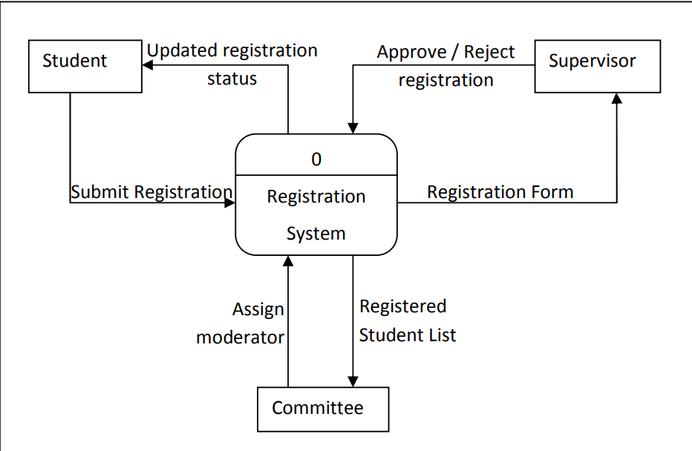

Figure 1: Context Diagram

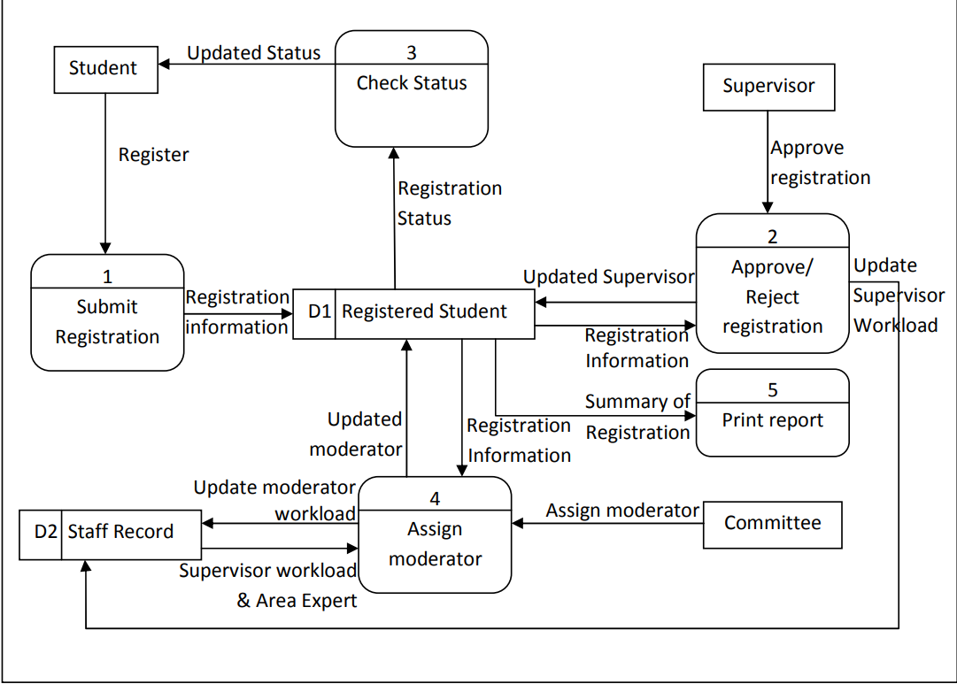

Figure 2: Level-0 Data Flow Diagram

5. Project Planning

5.1 Gantt Chart

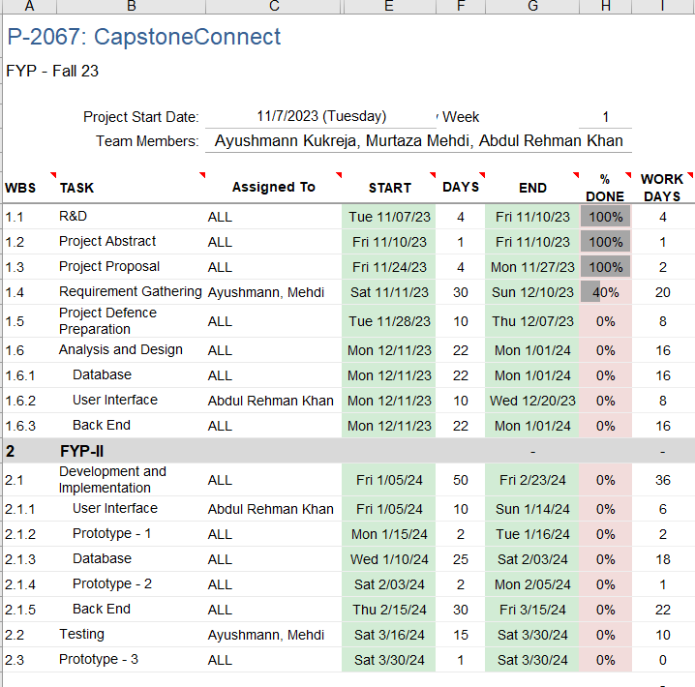
Figure 3: Gannt Chart

6. Project Requirements

6.1 Software tools requirements:

Front End: React.js is a popular JavaScript library for building user interfaces, developed by Facebook.
Back End: ASP.NET Core is a versatile, open-source framework for building modern, cloud-based, and cross-platform applications.
Database: (SQL Server Management Studio)
IDE: Visual Studio 2022

6.2 Hardware requirements

CPU: Opt for multicore processors like Intel Core i5/i7 or AMD Ryzen series for faster compilation and processing.
RAM: Ensure a minimum of 8GB RAM, with higher capacities (16GB or more) recommended for efficient multitasking and running development environments.
Storage: Prioritise SSDs (Solid State Drives) to enhance read/write speeds, facilitating quicker software builds and overall system performance.

7. Budget/Costing

7.1 Estimated Budgeted Cost of the Project

Total Hours - 1000 hrs
Per Hour Rate - 500 Rs
Total Hours Rate - 500,000 Rs

Total cost Rs. - 500,000 Rs

8. Project Deliverables:

8.1 Phase I - Alpha Prototype

The Alpha Prototype will be created by mid-January, which will contain interfaces of all the features (without implementation).
Expected Release: 01/23/2024

8.2 Phase II - Beta Prototype
The Beta Prototype will present detailed Database Working (Schemas, Tables, Relationships, and ERDs).
Expected Release: 2/18/2024

8.3 Phase III - Release Candidate
The Release Candidate will showcase a complete working application with all functionalities implemented on Backend.
Expected Release: 03/20/2024

8.4 Phase IV - Final Product
The Final Product will be delivered with complete documentation and deployment to all the affected members of the project.
Expected Release: 04/19/2024

9. Proposed GUI (Prototype)


Figure 4: Login for All Users
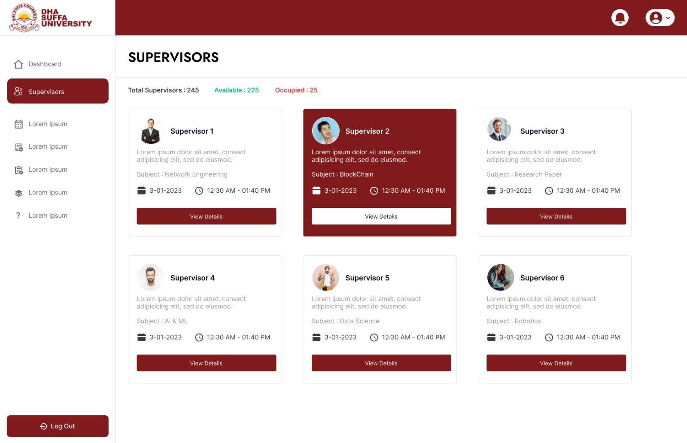
Figure 5: Student's Interface
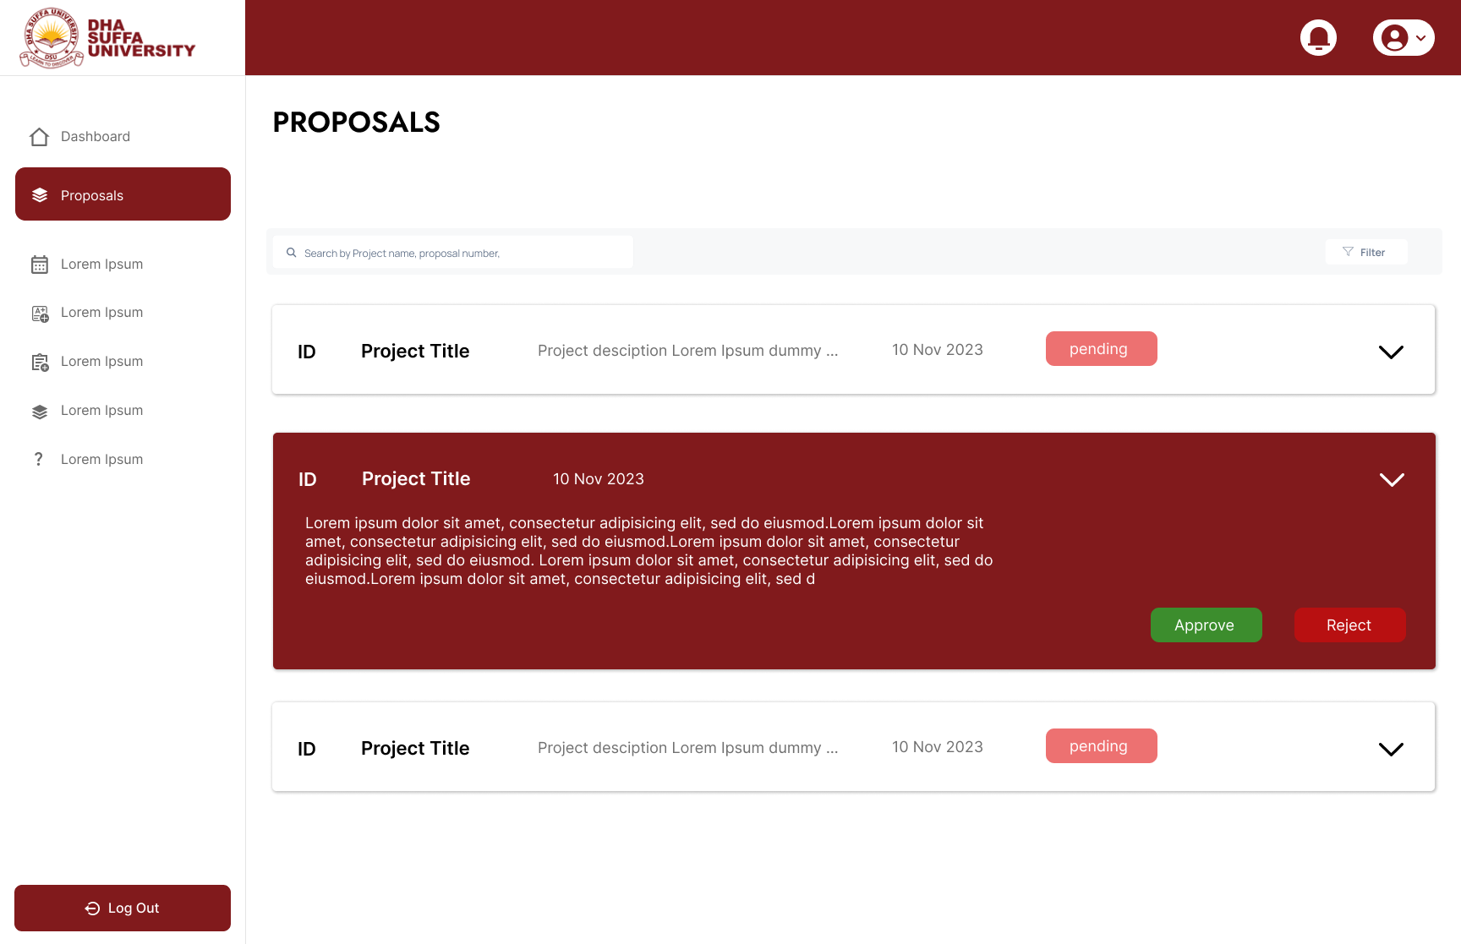
Figure 6: Supervisor’s Interface
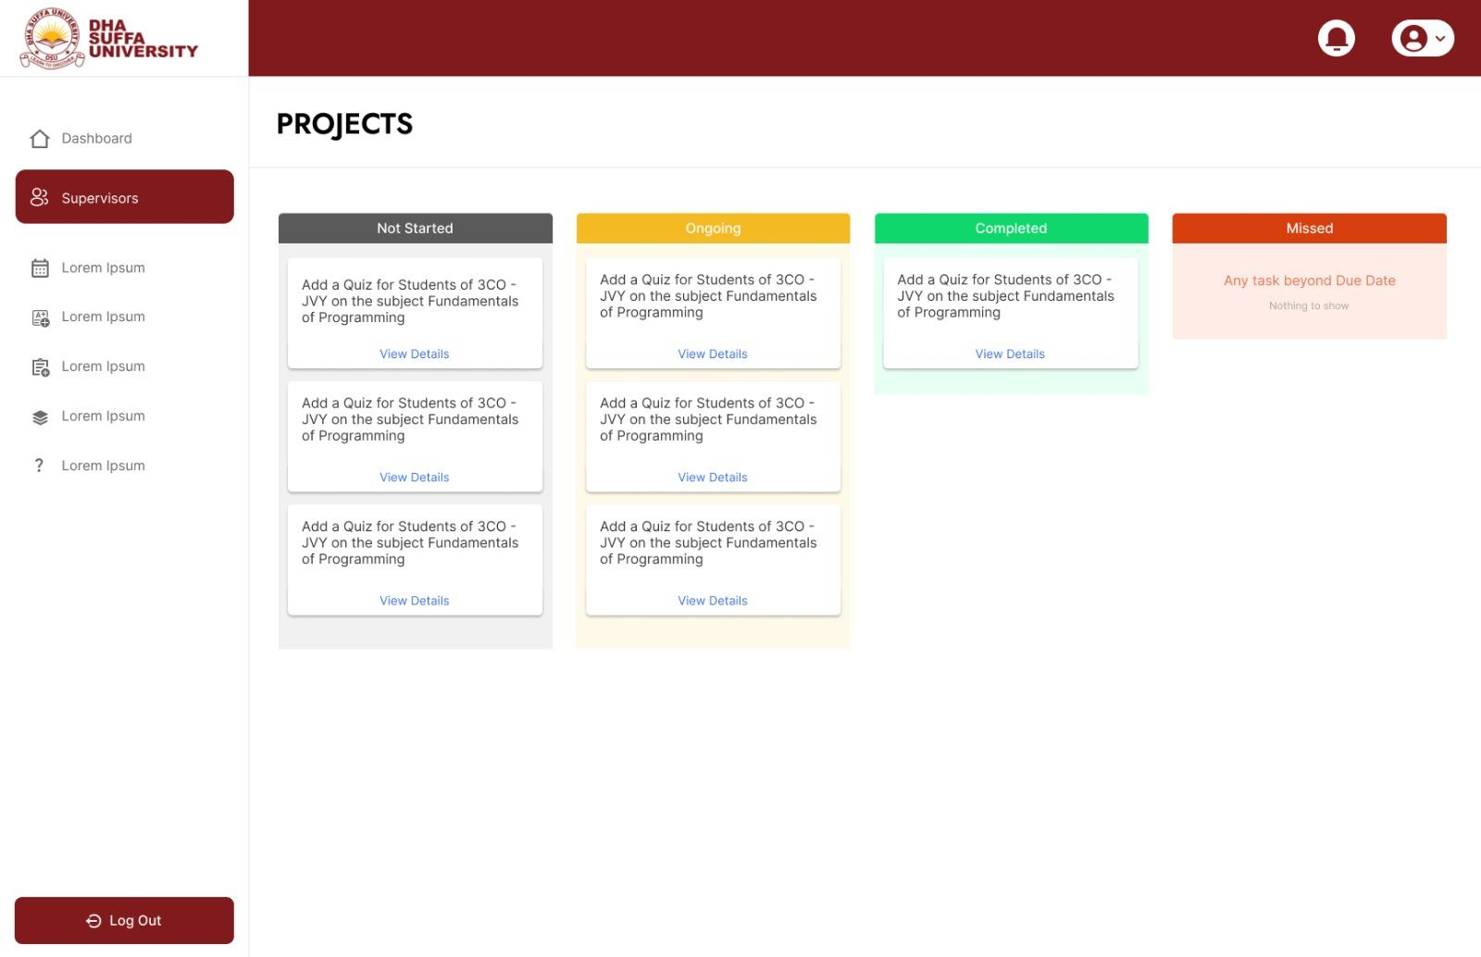
Figure 7: Supervisor’s Interface for assigned tasks

10 Meetings held with supervisor and/or client.

7/11/2023 - Idea was pitched by Supervisor to us. Ma’am Urooj Waheed explained how the current procedure of FYP is being done and how it could be improved.

10/11/2023 - This meeting was conducted by us, explaining our idea and vision about the project.

18/11/2023 - The purpose of this meeting was to gather requirements from university

